**WEEK 1:**

* We decided to do initial research separately and will work on the project together once we decide on what technologies to use.
* Thira: Working on LEGO Robot and hardware research and background work
* Nikunj: Working on Computer Vision, Deep Learning, and HoloLens App development Research and Background work
* Currently targeting kid’s story books only
* Children's books are different from normal books. They may have varying font sizes and styles, which may not necessarily be on the same line. Therefore, we need to provide a robust DL model that can handle all of these uncertainties

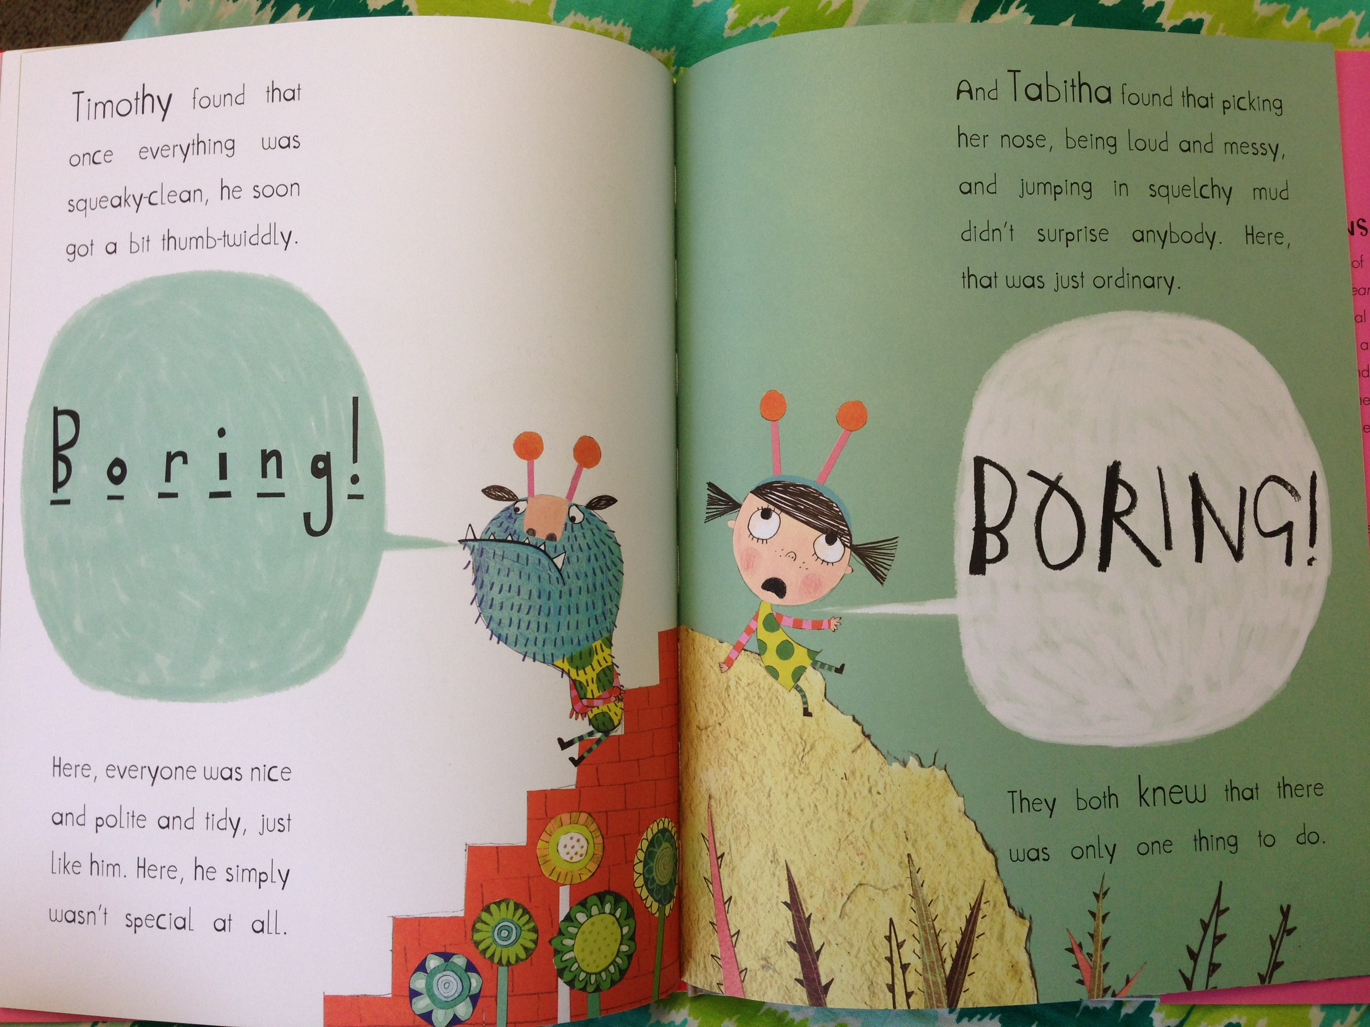

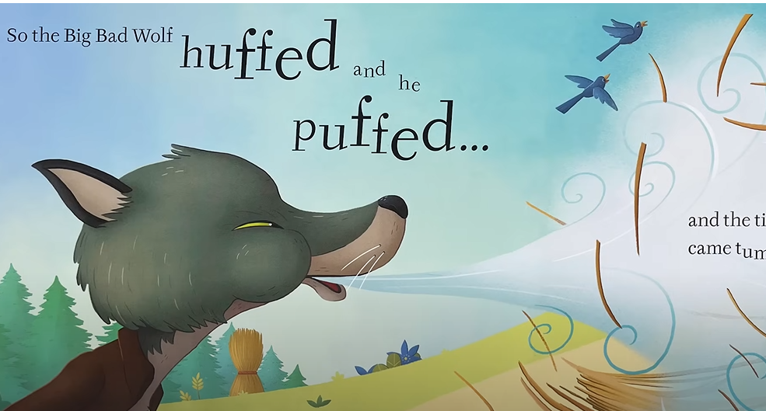

* Mixed reality Programming Guide
  + <https://www.google.com/books/edition/Beginning_Windows_Mixed_Reality_Programm/21pdzgEACAAJ?hl=en>

**Background research on how the storytelling using AR technology is beneficial to different audience:**

* Low ability reader
  + <https://vrphobia.com/Research/Publications/ARCTT2008.pdf#page=39>
  + Augmented reality has the potential to positively impact low ability readers by enhancing their reading experience and increasing their engagement. AR can provide visual aids and interactive elements that complement the text and make it more accessible to readers with different learning abilities
* Parents' UX on AR books
  + <https://link.springer.com/article/10.1007/s11423-018-9611-0>
  + In terms of Parent child relationship’s impact on the development of AR-based book reading devices, this paper provides insights into the needs and expectations of parents as potential users of such devices. It highlights the importance of creating AR content that is not only engaging and educational but also personalized and interactive, while also addressing concerns around screen time
* Comparing reading comprehension between children reading augmented reality and print storybooks
  + <https://www.sciencedirect.com/science/article/abs/pii/S0360131520300993>
  + The study found that the AR-based storybook was effective in improving children's engagement and learning outcomes compared to a traditional book. The interactive features of the AR-based storybook, such as 3D models and animations, helped to create a more immersive and interactive learning experience for children.

**WEEK 2 & 3:**

**LEGO robot:**

**REVIEW PAPER:**

Causo, A., Vo, G.T., Chen, IM., Yeo, S.H. (2016). Design of Robots Used as Education Companion and Tutor. In: Zeghloul, S., Laribi, M., Gazeau, JP. (eds) Robotics and Mechatronics. Mechanisms and Machine Science, vol 37. Springer, Cham. <https://doi.org/10.1007/978-3-319-22368-1_8>

* Look into the design robots discussed in paper.

**RESEARCH PAPERS:**

Chatzopoulos, Avraam, Michail Kalogiannakis, Stamatis Papadakis, and Michail Papoutsidakis. 2022. "A Novel, Modular Robot for Educational Robotics Developed Using Action Research Evaluated on Technology Acceptance Model" Education Sciences 12, no. 4: 274. <https://doi.org/10.3390/educsci12040274>

Nunez, Eleuda, Masakazu Hirokawa, and Kenji Suzuki. 2018. "Design of a Huggable Social Robot with Affective Expressions Using Projected Images" Applied Sciences 8, no. 11: 2298. <https://doi.org/10.3390/app8112298>

Li, J., Chignell, M. Communication of Emotion in Social Robots through Simple Head and Arm Movements. *Int J of Soc Robotics* **3**, 125–142 (2011). <https://doi.org/10.1007/s12369-010-0071-x>

MECHANICAL DESIGN OF THE HUGGABLE ROBOT PROBO KRISTOF GORIS, JELLE SALDIEN, BRAM VANDERBORGHT, and DIRK LEFEBER, International Journal of Humanoid Robotics 2011 08:03, 481-511. <https://doi.org/10.1142/S0219843611002563>

* Refer to frame and covering section.

Simon Zimmermann, Roi Poranne, James M. Bern, and Stelian Coros. 2019. PuppetMaster: robotic animation of marionettes. ACM Trans. Graph. 38, 4, Article 103 (August 2019), 11 pages. <https://doi.org/10.1145/3306346.3323003>

**MIT THESIS:**

Setapen, Adam (Adam Michael), 2012, “Creating robotic characters for long-term interaction”, <http://hdl.handle.net/1721.1/77813>

**BOOK:**

Robotics in Education, <https://doi.org/10.1007/978-3-030-82544-7>

**Robots in market:**

* Emo- <https://youtu.be/abqUMxj-1WI>
* Eilik- <https://youtu.be/SRLbpklaOSc>
* Loona- <https://youtu.be/tG0CKXLLLAA>
* Buddy- <https://youtu.be/JfJ1kNoWYhs>

Deep Learning and Computer Vision:

**Findings on how to deploy DL model into HoloLens and HoloLens 2 App Development Pipeline:**

* DL model deployment using WinML -> learn about WinML
  + Can also convert text to audio
  + Image detection and audio-to-speech example
    - <https://github.com/reneschulte/WinMLExperiments>
  + Custom Vision to train model
    - <https://www.customvision.ai/>
* Azure Spatial Anchors
  + <https://learn.microsoft.com/en-us/azure/spatial-anchors/overview>
* Mixed Reality Development
  + <https://learn.microsoft.com/en-us/windows/mixed-reality/develop/development?culture=en-us&country=us>
* Develop Mixed reality App on HoloLens 2
  + <https://learn.microsoft.com/en-us/training/paths/beginner-hololens-2-tutorials/>
* WinML uses ONNX models.
* WinML tagged questions on Stack Overflow:
  + <https://stackoverflow.com/questions/tagged/windows-machine-learning>
* Example of Deployment:
  + <https://github.com/doughtmw/HoloLens2-Machine-Learning>

**Deep Learning Model Research:**

* Objective: To detect text and parse it to extract meaning from it and communicate with the hardware on the LEGO robot
* Need: Text (varying fonts + styles + rotation + lightning + skewness etc)
* Common OCR practice:
  + Image preprocessing to remove noise
  + Text Detection -> where is the text -> bounding boxes
  + Text Recognition

**Deep Learning papers:**

* VS Transformer for Scene Text Recognition (<https://www.semanticscholar.org/reader/75235dc4bb53898868f5346c2d77d9eefaea6188>)
  + Pros
    - The VST method uses a self-attention mechanism that can selectively focus on relevant features of the input image and text, which can improve robustness to noise and distortion in the input.
    - The VST method is an end-to-end architecture that jointly optimizes both the text recognition and visual feature extraction steps, which can simplify the overall pipeline and reduce the risk of error propagation.
  + Cons
    - High computational cost
    - Difficult to interpret errors
* Text Detection and Recognition in the Wild: Review (<https://arxiv.org/abs/2006.04305>)
* Transformer based text detection in the wild (<https://openaccess.thecvf.com/content/CVPR2021W/VOCVALC/papers/Raisi_Transformer-Based_Text_Detection_in_the_Wild_CVPRW_2021_paper.pdf>)
  + Pros:
    - Can detect texts in the wild
  + Cons:
    - Computationally expensive since it is made of several architectures
* ASTER: An Attentional Scene Text Recognizer with Flexible Rectification ( <https://ieeexplore.ieee.org/abstract/document/8395027> )
  + GitHub: <https://github.com/bgshih/aster>
  + In this work, end-to-end text recognition is addressed in a two-stage manner, meaning the detection is performed in another network using separate features. ASTER performs implicit text detection. But this detection capability is limited to a small range near the target text. Expanding this range to the full image would yield a one-stage, end-to-end recognition system.
  + Pros:
    - Text detection in wild with rotation, brightness, font size and style invariant
    - Even detects words with spline structure
  + Cons:
    - While the attention mechanism in ASTER can improve performance, it also increases the computational cost of the method. This may limit its usability in certain applications where real-time processing or low-power requirements are important.
* Textboxes++: A Single-Shot oriented scene text detector(<https://arxiv.org/pdf/1801.02765.pdf>)
  + GitHub(<https://github.com/MhLiao/TextBoxes_plusplus>)
  + FCNN + VGG-16+ CNN and 6 Text-box layers connected to 6 intermediate convolutional layers. Each location of a text-box layer predicts an n-dimensional vector for each default box consisting of the text presence scores (2 dimensions), horizontal bounding rectangles offsets (4 dimensions), and rotated rectangle bounding box offsets (5 dimensions) or quadrilateral bounding box offsets (8 dimensions). A non-maximum suppression is applied during test phase to merge the results of all 6 text-box layers. Note that “#c” stands for the number of channels.
  + Pros:
    - Can detect words in wild
    - The proposed method is computationally efficient and can detect text quickly in natural scene images
    - The proposed approach uses a unified network to perform both text detection and recognition, eliminating the need for multiple stages and improving overall efficiency
    - The proposed method is able to detect text in a variety of orientations and lighting conditions
    - Can detect slant words
    - Can detect words with spline structure
    - Word proposals around highly cluttered environment
  + Cons:
    - Due to limited dataset training, it’s hard for it to detect unknown text from other datasets
    - Sometimes false predictions in high cluttered environment
* Transformer-based Scene Text Recognition (Transformer-STR) (<https://github.com/opconty/Transformer_STR>)
* Vision Transformer for Fast and Efficient Scene Text Recognition
  + <https://www.semanticscholar.org/reader/fd68411473b8ddbfc869b8dee2d6107742fc4ab4>
* Vision Transformer for Fast and Efficient Scene Text Recognition
  + <https://github.com/roatienza/deep-text-recognition-benchmark>